KPPS P&C AGM
Meeting Minutes
Friday 23rd February 2024
Meeting opened 1:15 pm

Attendees: | Emma Snell, Belinda Dunn, Nicole Skiffington, Matthew West, Joy Buckley, Shaheen Shah, Irene Saye
Apologies: | nil
Absent:
Minutes: | Minutes prepared by Nicole Skiffington

Meeting opened – Nicole
Welcome and acknowledgement to country – Nicole
Overview of 2023
2023 was a very successful year for the KPPS P&C, despite our small size in member numbers we hade many successful events. Mother’s day, Father’s day and our end of year fun day in particular were great successes with the students. We had a pizza lunch day which the students were keen to repeat.
Meeting days – Nicole
During the last few weeks we had a survey running to obtain feedback from parents and the community on the best day to hold our monthly meetings moving forward. Based on the results we have found that a day change is required to gather extra members and community members to assist us in our events.
Nicole Moves a motion to change our monthly meeting day from Friday at 1pm to Wednesday at 2pm.
Belinda supports the motion, Matthew seconds. Motion approved.
This will also be amended in the by laws.
Amendment of Bylaws - Nicole
A proposal for the amendment of the KPPS P&C Bylaws has been put forward by Nicole. The amended by laws will be posted on the KPPS website in the P&C section with amendments highlighted in red. Once the amendments have been posted and viewed by the public, they will then be voted upon at the next meeting on Wednesday 27th March 2024.

P&C Executive/Committee members
Belinda Dunn, President of the P&C for 2023 declares all positions are now vacant as of Friday 23rd February 2024. Mrs Emma Snell as the returning officer for the committee takes over for the committee elections at 1:34pm. Accepting nominations for President, Vice President, Secretary and Treasurer.
Nicole Skiffington Nominates Belinda Dunn for President 2024. Belinda accepts the nomination. No further nominations are made. Belinda Dunn is declared President of KPPS P&C 2024.
Irene Saye nominates Joy Buckley for Vice President. Joy accepts the nomination. No further nominations are made. Joy Buckley is declare Vice President of KPPS P&C 2024.
Matthew West nominates Nicole Skiffington for Secretary. Nicole accepts the nomination. No further nominations are made. Nicole Skiffington is declared Secretary of KPPS P&C 2024.
Belinda Dunn nominates Matthew West for Treasurer. Matthew accepts the nomination. No further nominations are made. Matthew West is declare Treasurer for KPPS P&C 2024.
All positions are now filled. Congratulations to our New committee members for 2024. Emma Snell passes the meeting back to the president, Belinda Dunn at 1:48pm
Belinda passes the meeting back to Nicole.
Principal’s Report – Emma Snell
KPPS has had a fantastic start to 2024.
Unfortunately we have had a drop in students, 165 to 152, as our Kindy enrolments were not as large as we first thought. We have had 17 Kindy students enrol and due to this drop in numbers it has unfortunately affected staffing.
Teachers have amazingly received an 8.1% increase in the wages/pay rates, unfortunately that has affected the schools internal budgets for the year. Knowing this could be a possibility, Emma planned ahead to utilise the previous years budget to forward pay some of this years school events and maintenance within the school.
We have 8 classes from K-6 with 2 preschool groups. However in line with our student numbers we are supposed to have 6 classes from K-6.
There are 2 smaller classes that have been put together in order to help those students who need the extra academic support to reach their goals for this year.
Mrs Sharp – year 2/3 Class
Mrs Dundas – year 4/5 Class
The names of our classrooms will now be attached to our rooms and will continue on for each new student class within that room.
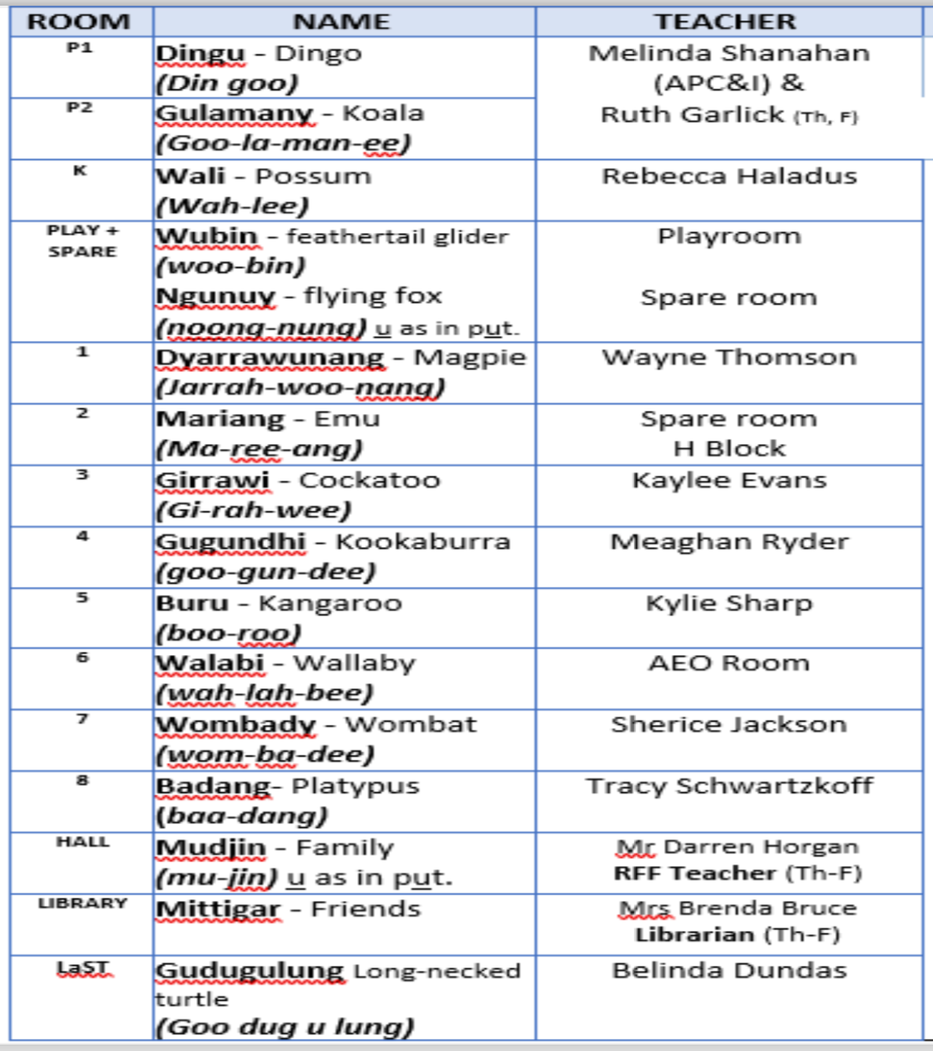
Across the school a new program has been put in place. Investing 3 hours per week to really help target those who need to focus on specific aspects within Literacy. Groups of 12 or less students, meet with a teacher or SLSO and target their overall English and literature skills. Phonics, letter sounds and fluency are some key aspects. Meeting 1 hour every Monday-Wednesdays.
Mrs Lauren Braley with the help of Miss Kaylee Evans continue to update and educate all our students on the Darug language.

Amplify Program is a music program that will be implemented within the school this year. It is a program of online music lessons with qualified teachers. Cranebrook High school has graciously donated their Xylophones to assist us with this new program.

School Bytes and My Family Hand are our new communication Apps for parents and teachers. All notes are now online, with signatures and payments being made through the School Bytes app and reminders for all events, notes to be signed and even deadlines for payments coming through the My Family Hand app are incredible useful and eliminate the extra use of paper and lost notes.

Most Incursions for the students have been paid for by the school this year, any excursions that require a bus trip will be charge between $15 and $20 depending on the distance of travel. Entry fees will be included if necessary.
For this years camp the students will be traveling to Point Wollstonecraft for 3 days and 2 nights. We have a Grant coming to assist as the total cost is over $500 and we hope to only charge $250 for this trip with the hope that parents will be able to cover this amount for the children to attend.

This year we have been able to organise the staff and school timetable for the SLSOs to be able to assist in every classroom for the majority of the school days. This has been helped along with the School Bytes and My Family Hand apps.

Unfortunately we have had another break-in within the school. They accessed the Canteen and stole a case of coke zero, a tray of sausages and a loaf of bread. Other local schools have also experienced break and enters. Measures have been taken to ensure all office equipment is safe and protected. Security systems are being rectified despite the old systems.
Treasurer’s Report
Current account balance is : $6312.45
Insurances to be paid amount to $1003.00
Mother’s day stall will be held on the Wednesday 8th May 2024.
Belinda moves a motion to approve $2000.00 to spend on purchases for the mother’s day stall.
Matthew Supports the motion. Nicole seconds the motion. Motion approved.
Shaheen and Irene will place the order and forward any invoices to the P&C email to be paid.
Next meeting will be held on the 27th March 2024 at 2pm in a room to be advised.
Meeting closed at 2:26pm

